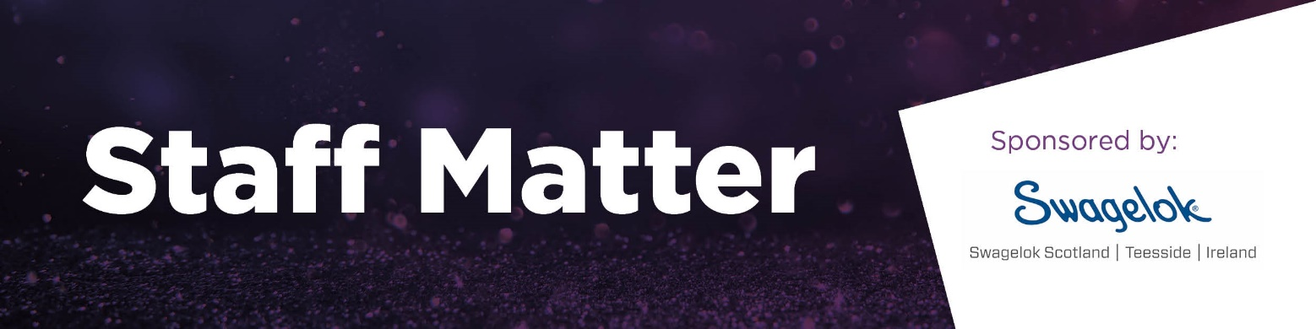
Awarded to a company that takes care of its people from milestone recognition, providing exceptional learning and personal development to promoting the values of equality, diversity, and inclusion so that its people take care of business.

Which company is being nominated?
Company name*
Address
*This will be printed on all Northern Star Business Awards promotional materials, awards, and print work.
Company contact?
Who should we contact to complete checklists, book the table, and send tickets, if selected as a finalist?
Contact name
Phone
Email

Your details?
If different to the above.
Contact name
Company
Phone
Email
Relationship to the company nominated

- Provide a brief description of the business, the products, or services it supplies, customers and the markets in which it operates. (Up to 200 words)
- Provide a description of the company’s approach to employee development and how this links with its business objectives. (Up to 300 words)
- What are the anticipated skills needs in the company and how are they being addressed? (Up to 250 words)
- Outline specific activities that have proved particularly effective for the business with regards to improved retention, reduced recruitment costs, and improvement to business growth and profits. (Up to 400 words)
- How is the company using its staff to create competitive advantage? (Up to 250 words)
- What is the perceived value of taking care of employees as an investment rather than cost?
(Up to 300 words)
- What other reasons do you attribute to the nominee’s success? (Up to 100 words)

Nomination Guidelines

Judging
Our judging panel consists of independent experts, representatives from the Chamber board, policy group and sponsors who will select a shortlist for each category. All those shortlisted will be notified on Friday 21 November 2025 and winners will be announced at the Northern Star Business Awards dinner on Friday 17 April 2026 at P&J Live.

The rules
- The Northern Star Business Awards are open to all businesses but they must be based in Aberdeen City or Aberdeenshire.
- All third-party nominations must be made with the full knowledge and co-operation of the nominee.
- All submissions should relate to activity within the nominee’s most recent financial year, unless stated otherwise in the application form.
- Information companies do not wish publicised should be clearly marked as ‘CONFIDENTIAL’.
- Completed forms must be signed by a representative of the company.
- Nominations can be made for a maximum of two categories.
- Aberdeen & Grampian Chamber of Commerce will not accept responsibility for loss or damage to entries.
- Aberdeen & Grampian Chamber of Commerce reserves the right to not make an award in any category if no satisfactory nominations are received.
- Judges must declare any interests with nominees.
- The judges’ decision is final.
- Finalists must participate in interviews and photo shoots to promote the Northern Star Business Awards 2026.
- Finalists will be issued with dates for filming; these must be adhered to, and no alternative dates will be provided.
- Finalists will be listed on our Northern Star Business Awards webpage and shared via the Chamber’s marketing channels.
- If you have a winning entry, the data you provide in the nomination will be used for the Winners Review content (unless marked CONFIDENTIAL).
- Finalists must book a minimum of one place at the awards ceremony taking place on Friday 17 April 2026.

Key dates

Nominations close | Friday 26 September 2025
Finalists announced | Friday 21 November 2025
Awards night | Friday 17 April 2026

I have read the above rules and agree to abide by them:

Electronic signature:
Date:

